

Department of Electrical & Electronics Engineering

I Semester
Introduction to IoT Course Project(24EECF101)

SMART AUTOMATIC STREET LIGHT

Team members :4
Team Number :17
Name | USN | Roll No
Basavaraj Sattigeri | 01FE25BEE068 | 2405
Omkar p patil | 01FE25BEE119 | 2448
Santosh haddannavar | 01FE25BEE118 | 2447
Mahantesh Bk | 01FE25BEE112 | 2441

Academic Year : 2024-2025

i
Content |  | Pg No
Abstract
1 | Introduction
 | 1.1 Problem Statement
 | 1.2 Introduction
2 | Methodology
3.1 Block Diagram
3.2 Flowchart
3.3 Details about components used
3.4 Bill of Materials
3.5 Explanation about project working in detail
5 | Results and Discussion  5.1 Screenshots of prototype  5.2 Results explanation  5.3 Code
6 | Conclusion

INTRODUCTION :
1.1 Problem statement
The conventional street lighting system consumes excessive energy by staying ON all night regardless of traffic or pedestrian presence, leading to high electricity costs, reduced lamp life, and unnecessary carbon emissions. It lacks automation, relying on manual or timer-based switching that cannot adapt to real-time conditions, which compromises safety and efficiency. The objective of an automatic smart street light system is to use sensors to detect ambient light and movement, automatically controlling brightness or switching lights ON/OFF to save energy, reduce costs, extend lamp life, and improve public safety while enabling future IoT-based monitoring.
Introduction
The Smart Street Light System is an innovative solution designed to overcome the limitations of traditional street lighting by integrating automation, sensors, and energy-efficient technology. Unlike conventional lights that remain ON throughout the night, smart street lights automatically adjust their operation based on ambient light levels and the presence of vehicles or pedestrians. Using components such as LDRs, PIR sensors, and microcontrollers, the system ensures that lights switch ON only when needed and dim or turn OFF when the area is vacant, significantly reducing energy consumption and operational costs. This approach not only enhances public safety by providing reliable illumination but also supports sustainability goals by minimizing carbon emissions and extending lamp life. Additionally, smart street lights can be integrated with IoT platforms for remote monitoring and control, making them scalable and adaptable for modern smart cities.

2. METHODOLOGY
The smart street light system is designed using a sensor-based automation approach controlled by a microcontroller. The methodology involves integrating Light Dependent Resistors (LDRs) to detect ambient light levels and PIR/IR sensors to sense the movement of pedestrians or vehicles. During daylight, the LDR keeps the lights OFF, while at night the system activates only when motion is detected, thereby conserving energy. The microcontroller (Arduino/ESP32) processes sensor inputs and controls the LED street lights accordingly. Power is supplied through a regulated source, and the system is tested under varying conditions to ensure reliability, efficiency, and safety. The methodology emphasizes energy optimization, automation, and scalability, with provisions for future IoT integration to enable remote monitoring and control.

2.1 circuit Diagram
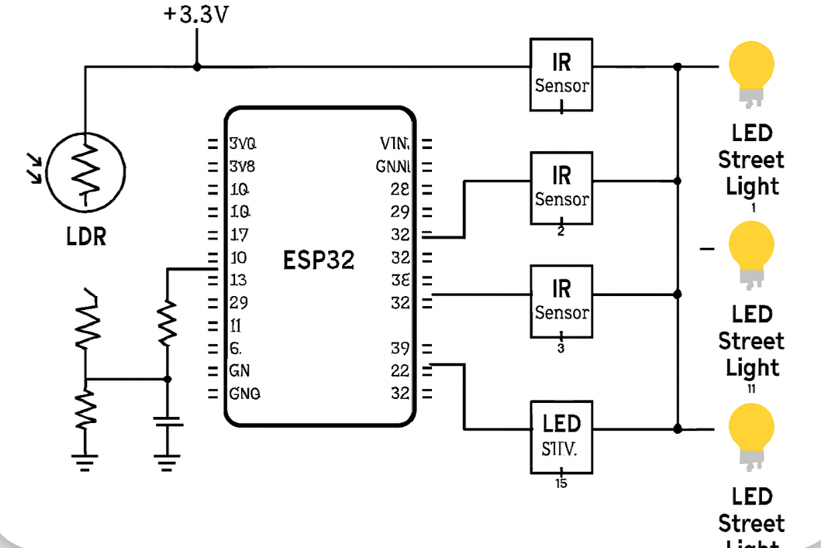

2.2 Block diagram
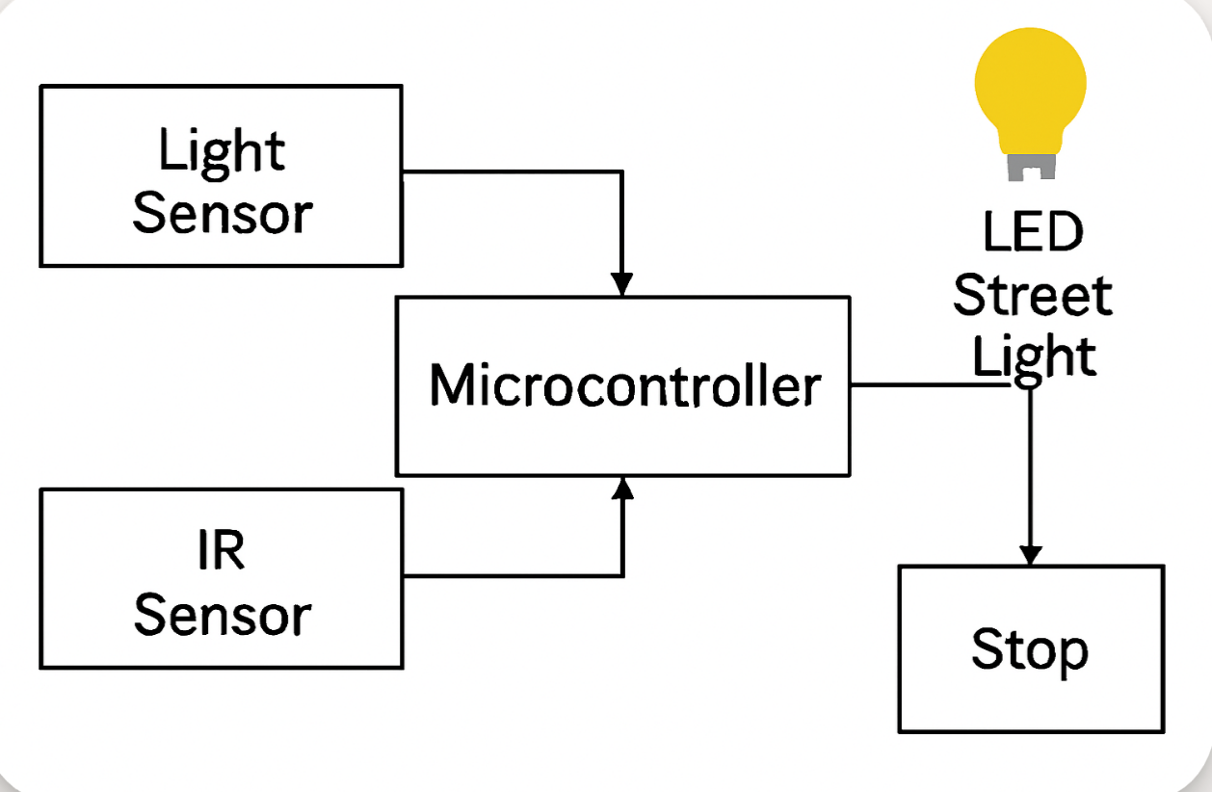

2.3 Flow chart
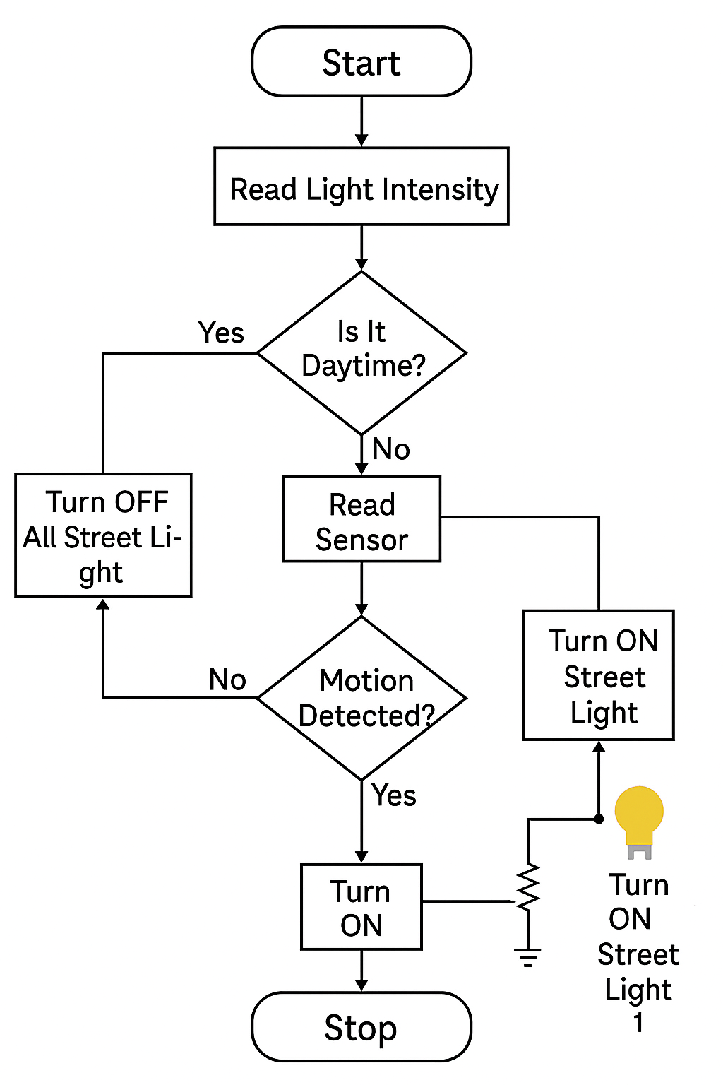

2.3 Details About Components Used

1.ESP 32 : Main controller of the system.
2. IR Sensor : Detects the vehicle movement.
3. Relay Module : Switches the street light ON/OFF.
4. LED : Used as street light model.
5. Power supply : Provides required voltage.
6. Jumper wires

2.4 Bill Of materials

2.5 Explaination Of Project Working :
Objectives :
• Reduce energy consumption using automatic lighti
• Display available parking spaces in real time
• Improve smart city infrastructure
Components
1.ESP 32 : Main controller of the system.
2. IR Sensor : Detects the vehicle movement.
3. Relay Module : Switches the street light ON/OFF.
4. LED : Used as street light model.
5. Power supply : Provides required voltage.
6. LED Bulbs:
Indicate specific water levels:Green: Water level is adequate.Yellow: Water is below the desired level.Red: Water is critically low or high.
7. Wi-Fi:ESP32
connects to the internet to send water level data to a server or app.---Working Principle
1. Water Level the data and determines the level of water
Measurement:
The ultrasonic sensor emits sound waves.The waves bounce back from the water surface.The time taken for the waves to return is measured, and the water level is calculated.
2. Data Processing:The ESP32 processes the data and determines the level of water (e.g., percentage full).
3. Alerts & Automation :
If the water level falls below a certain point, the ESP32 activates the relay to start the pump.If the tank is full, the relay stops the pump and triggers a buzzer and/or LEDs for alerts.
4. IoT Integration:
The ESP32 sends the water level data to a cloud server or a mobile app via Wi-Fi.Users can view the real-time water level remotely and receive notifications

3.1 Screenshot Of prototype

3.2 Code for Program
#define BLYNK_PRINT Serial

#define BLYNK_TEMPLATE_ID "TMPL3p1EbpWpQ"
#define BLYNK_TEMPLATE_NAME "Street Light"
#define BLYNK_AUTH_TOKEN "l9sqUBTl60fHOnNO4IHCR1S4Pt0GKW8U"

#include <WiFi.h>
#include <BlynkSimpleEsp32.h>

// WiFi credentials
char ssid[] = "moto g85_3291"
char pass[] = "123456789"

// Pins
#define LDR_PIN 34
#define IR1_PIN 26
#define IR2_PIN 27
#define IR3_PIN 33

#define LED1_PIN 18
#define LED2_PIN 19
#define LED3_PIN 32

bool lastLightState = false; // To track ON/OFF state

void setup() {
Serial.begin(115200);

pinMode(IR1_PIN, INPUT);
pinMode(IR2_PIN, INPUT);
pinMode(IR3_PIN, INPUT);

pinMode(LED1_PIN, OUTPUT);
pinMode(LED2_PIN, OUTPUT);
pinMode(LED3_PIN, OUTPUT);

Blynk.begin(BLYNK_AUTH_TOKEN, ssid, pass);
}

void loop() {
Blynk.run();

int ldrValue = analogRead(LDR_PIN); // 0–4095
int ir1State = digitalRead(IR1_PIN); // LOW = object detected
int ir2State = digitalRead(IR2_PIN);
int ir3State = digitalRead(IR3_PIN);

bool isDay = (ldrValue > 2000);
bool lightsOn = false;

if (isDay) {
digitalWrite(LED1_PIN, LOW);
digitalWrite(LED2_PIN, LOW);
digitalWrite(LED3_PIN, LOW);
lightsOn = false;
} else {
digitalWrite(LED1_PIN, (ir1State == LOW) ? HIGH : LOW);
digitalWrite(LED2_PIN, (ir2State == LOW) ? HIGH : LOW);
digitalWrite(LED3_PIN, (ir3State == LOW) ? HIGH : LOW);

if (ir1State == LOW || ir2State == LOW || ir3State == LOW) {
lightsOn = true;
}
}

// 🔔 Send notification only when state changes
if (lightsOn != lastLightState) {
if (lightsOn) {
Blynk.logEvent("street_lights_on");
Serial.println("Notification: Street lights ON");
} else {
Blynk.logEvent("street_lights_off");
Serial.println("Notification: Street lights OFF");
}
lastLightState = lightsOn;
}

delay(200);
}

4. Conclussion:

The automatic street light system is designed to save energy and improve safety by using sensors and microcontroller logic. An LDR detects ambient light to distinguish between day and night, ensuring that lights remain off during daylight hours. At night, IR sensors monitor movement of vehicles or pedestrians, and corresponding LEDs switch on only when activity is detected. This reduces unnecessary power consumption, minimizes human intervention, and provides reliable illumination when needed. The system is cost-effective, eco-friendly, and scalable, making it suitable for smart city applications where efficiency and automation are priorities

